import pandas as pd
import numpy as np
import seaborn as sns
import matplotlib.pyplot as plt
import warnings
warnings.filterwarnings(action="ignore")
from sklearn.model_selection import train_test_split
from sklearn.metrics import accuracy_score, classification_report
from sklearn.svm import SVC
from imblearn.over_sampling import SMOTE
from sklearn.ensemble import AdaBoostClassifier
from sklearn.metrics import roc_curve, auc
from sklearn import metrics
from sklearn.metrics import confusion_matrix
from sklearn.datasets import make_classification
from sklearn.metrics import accuracy_score, precision_score, recall_score, f1_score
C:\Users\agarw\anaconda3\lib\site-packages\scipy\__init__.py:146: UserWarning: A NumPy version >=1.16.5 and <1.23.0 is required for this version of SciPy (detected version 1.26.2
warnings.warn(f"A NumPy version >={np_minversion} and <{np_maxversion}"
#importing data from the dataset
df = pd.read_csv(r"C:\Users\agarw\OneDrive\Desktop\Dissertation\data.csv")
#checking for bankrupt companies 0 is non-bankrupt and 1 is bankrupt
bankrupt_data = df['Bankrupt?'].value_counts()
bankrupt_data
Bankrupt?
0 6599
1 220
Name: count, dtype: int64
#Distribution representation
plt.figure(figsize = (10,5))
colors = ["#3498db", "#e74c3c"]
ax = sns.countplot(x=df['Bankrupt?'], data=df,palette=colors)
for p in ax.patches:
ax.annotate(f'{p.get_height()}', (p.get_x() + p.get_width() / 2., p.get_height()),
ha='center', va='center', xytext=(0, 10), textcoords='offset points')
# Add labels and title
plt.xlabel('Bankrupt')
plt.ylabel('Count')
plt.title('Distribution of Bankrupt')
# Show the plot
plt.show()
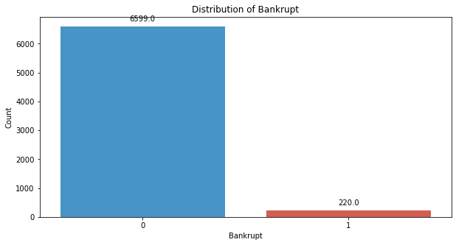
# seperate the Bankrupt label from the dataset
y = df['Bankrupt?']
X = df.drop(['Bankrupt?'], axis = 1)
# divinding our dataset into training dataset
X_train, X_temp, y_train, y_temp = train_test_split(X, y, test_size=0.2, random_state=42)
#Distribution representation
plt.figure(figsize = (10,5))
colors = ["#3498db", "#e74c3c"]
ax = sns.countplot(x=y_train, data=df,palette=colors)
for p in ax.patches:
ax.annotate(f'{p.get_height()}', (p.get_x() + p.get_width() / 2., p.get_height()),
ha='center', va='center', xytext=(0, 10), textcoords='offset points')
# Add labels and title
plt.xlabel('Bankrupt')
plt.ylabel('Count')
plt.title('Distribution of Bankrupt')
# Show the plot
plt.show()
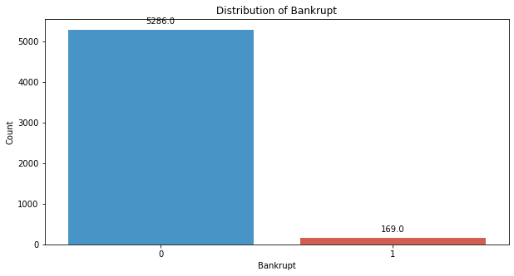
# divinding our dataset into testing and validation
X_val, X_test, y_val, y_test = train_test_split(X_temp, y_temp, test_size=0.5, random_state=42)
smote = SMOTE(sampling_strategy=1,random_state=42)
X_train_resampled, y_train_resampled = smote.fit_resample(X_train, y_train)
#Distribution representation
plt.figure(figsize = (10,5))
colors = ["#3498db", "#e74c3c"]
ax = sns.countplot(x=y_train_resampled, data=df,palette=colors)
for p in ax.patches:
ax.annotate(f'{p.get_height()}', (p.get_x() + p.get_width() / 2., p.get_height()),
ha='center', va='center', xytext=(0, 10), textcoords='offset points')
# Add labels and title
plt.xlabel('Bankrupt')
plt.ylabel('Count')
plt.title('Distribution of Bankrupt')
# Show the plot
plt.show()
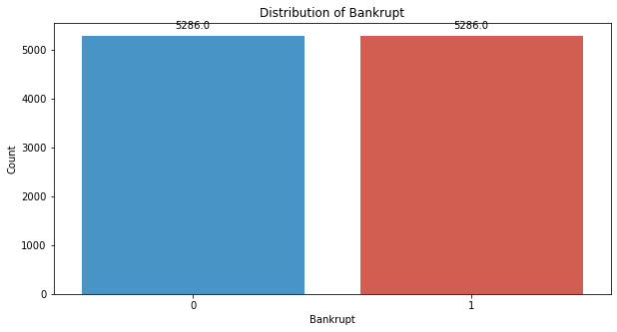
svm_classifier_poly = SVC(kernel='poly', random_state=42)
svm_classifier_poly.fit(X_train_resampled, y_train_resampled)
SVC(kernel='poly', random_state=42)
y_val_pred_poly = svm_classifier_poly.predict(X_val)
# Evaluate the model's performance on the validation set
val_accuracy = accuracy_score(y_val, y_val_pred_poly)
precision = precision_score(y_val, y_val_pred_poly)
recall = recall_score(y_val, y_val_pred_poly)
f1_value = f1_score(y_val, y_val_pred_poly)
val_report = classification_report(y_val, y_val_pred_poly)
print("Accuracy", val_accuracy)
print("Precision", precision)
print("Recall", recall)
print("F1 Score", f1_value)
print("Validation Classification Report:\n", val_report)
Accuracy 0.6304985337243402
Precision 0.05384615384615385
Recall 0.7
F1 Score 0.1
Validation Classification Report:
precision recall f1-score support
0 0.99 0.63 0.77 662
1 0.05 0.70 0.10 20
accuracy 0.63 682
macro avg 0.52 0.66 0.43 682
weighted avg 0.96 0.63 0.75 682
conf_matrix = confusion_matrix(y_val, y_val_pred_poly)
print("Confusion Matrix")
print(conf_matrix)
Confusion Matrix
[[416 246]
[ 6 14]]
y_test_pred_poly = svm_classifier_poly.predict(X_test)
# Evaluate the model's performance on the test set
test_accuracy = accuracy_score(y_test, y_test_pred_poly)
precision = precision_score(y_test, y_test_pred_poly)
recall = recall_score(y_test, y_test_pred_poly)
f1_value = f1_score(y_test, y_test_pred_poly)
test_report = classification_report(y_test, y_test_pred_poly)
print("Accuracy", test_accuracy)
print("Precision", precision)
print("Recall", recall)
print("F1 Score", f1_value)
print("Test Classification Report:\n", test_report)
Accuracy 0.6466275659824047
Precision 0.07317073170731707
Recall 0.5806451612903226
F1 Score 0.12996389891696752
Test Classification Report:
precision recall f1-score support
0 0.97 0.65 0.78 651
1 0.07 0.58 0.13 31
accuracy 0.65 682
macro avg 0.52 0.62 0.45 682
weighted avg 0.93 0.65 0.75 682
conf_matrix = confusion_matrix(y_test, y_test_pred_poly)
print("Confusion Matrix")
print(conf_matrix)
Confusion Matrix
[[423 228]
[ 13 18]]
# Compute ROC curve and ROC area for each class
fpr_val, tpr_val, _ = roc_curve(y_val, y_val_pred_poly)
roc_auc_val = auc(fpr_val, tpr_val)
fpr_test, tpr_test, _ = roc_curve(y_test, y_test_pred_poly)
roc_auc_test = auc(fpr_test, tpr_test)
# Plot ROC curve
plt.figure(figsize=(8, 8))
plt.plot(fpr_val, tpr_val, color='darkorange', lw=2, label=f'Validation ROC curve (area = {roc_auc_val:.2f})')
plt.plot(fpr_test, tpr_test, color='green', lw=2, label=f'Test ROC curve (area = {roc_auc_test:.2f})')
plt.plot([0, 1], [0, 1], color='navy', lw=2, linestyle='--')
plt.xlim([0.0, 1.0])
plt.ylim([0.0, 1.05])
plt.xlabel('False Positive Rate')
plt.ylabel('True Positive Rate')
plt.title('Receiver Operating Characteristic (ROC) Curve')
plt.legend(loc="lower right")
plt.show()
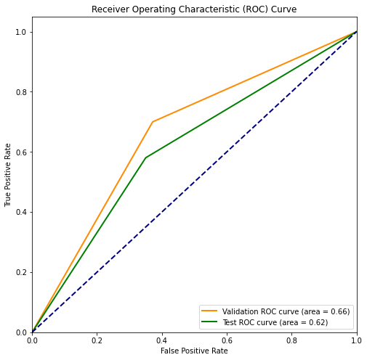
svm_classifier_rbf = SVC(kernel='rbf', random_state=42)
svm_classifier_rbf.fit(X_train_resampled, y_train_resampled)
SVC(random_state=42)
y_val_pred_rbf = svm_classifier_rbf.predict(X_val)
# Evaluate the model's performance on the validation set
val_accuracy = accuracy_score(y_val, y_val_pred_rbf)
precision = precision_score(y_val, y_val_pred_rbf)
recall = recall_score(y_val, y_val_pred_rbf)
f1_value = f1_score(y_val, y_val_pred_rbf)
val_report = classification_report(y_val, y_val_pred_rbf)
print("Accuracy", val_accuracy)
print("Precision", precision)
print("Recall", recall)
print("F1 Score", f1_value)
print("Validation Classification Report:\n", val_report)
Accuracy 0.7639296187683284
Precision 0.08284023668639054
Recall 0.7
F1 Score 0.14814814814814817
Validation Classification Report:
precision recall f1-score support
0 0.99 0.77 0.86 662
1 0.08 0.70 0.15 20
accuracy 0.76 682
macro avg 0.54 0.73 0.51 682
weighted avg 0.96 0.76 0.84 682
conf_matrix = confusion_matrix(y_val, y_val_pred_rbf)
print("Confusion Matrix")
print(conf_matrix)
Confusion Matrix
[[507 155]
[ 6 14]]
y_test_pred_rbf = svm_classifier_rbf.predict(X_test)
# Evaluate the model's performance on the test set
test_accuracy = accuracy_score(y_test, y_test_pred_rbf)
precision = precision_score(y_test, y_test_pred_rbf)
recall = recall_score(y_test, y_test_pred_rbf)
f1_value = f1_score(y_test, y_test_pred_rbf)
test_report = classification_report(y_test, y_test_pred_rbf)
print("Accuracy", test_accuracy)
print("Precision", precision)
print("Recall", recall)
print("F1 Score", f1_value)
print("Test Classification Report:\n", test_report)
Accuracy 0.7595307917888563
Precision 0.08695652173913043
Recall 0.45161290322580644
F1 Score 0.14583333333333334
Test Classification Report:
precision recall f1-score support
0 0.97 0.77 0.86 651
1 0.09 0.45 0.15 31
accuracy 0.76 682
macro avg 0.53 0.61 0.50 682
weighted avg 0.93 0.76 0.83 682
conf_matrix = confusion_matrix(y_test, y_test_pred_rbf)
print("Confusion Matrix")
print(conf_matrix)
Confusion Matrix
[[504 147]
[ 17 14]]
# Compute ROC curve and ROC area for each class
fpr_val, tpr_val, _ = roc_curve(y_val, y_val_pred_rbf)
roc_auc_val = auc(fpr_val, tpr_val)
fpr_test, tpr_test, _ = roc_curve(y_test, y_test_pred_rbf)
roc_auc_test = auc(fpr_test, tpr_test)
# Plot ROC curve
plt.figure(figsize=(8, 8))
plt.plot(fpr_val, tpr_val, color='darkorange', lw=2, label=f'Validation ROC curve (area = {roc_auc_val:.2f})')
plt.plot(fpr_test, tpr_test, color='green', lw=2, label=f'Test ROC curve (area = {roc_auc_test:.2f})')
plt.plot([0, 1], [0, 1], color='navy', lw=2, linestyle='--')
plt.xlim([0.0, 1.0])
plt.ylim([0.0, 1.05])
plt.xlabel('False Positive Rate')
plt.ylabel('True Positive Rate')
plt.title('Receiver Operating Characteristic (ROC) Curve')
plt.legend(loc="lower right")
plt.show()
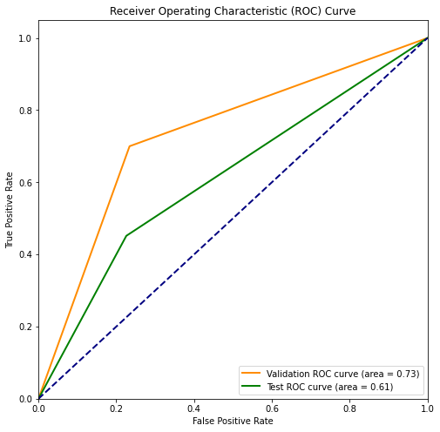
svm_classifier_sigmoid = SVC(kernel='sigmoid', random_state=42)
svm_classifier_sigmoid.fit(X_train_resampled, y_train_resampled)
SVC(kernel='sigmoid', random_state=42)
y_val_pred_sigmoid = svm_classifier_sigmoid.predict(X_val)
# Evaluate the model's performance on the validation set
val_accuracy = accuracy_score(y_val, y_val_pred_sigmoid)
precision = precision_score(y_val, y_val_pred_sigmoid)
recall = recall_score(y_val, y_val_pred_sigmoid)
f1_value = f1_score(y_val, y_val_pred_sigmoid)
val_report = classification_report(y_val, y_val_pred_sigmoid)
print("Accuracy", val_accuracy)
print("Precision", precision)
print("Recall", recall)
print("F1 Score", f1_value)
print("Validation Classification Report:\n", val_report)
Accuracy 0.4032258064516129
Precision 0.022222222222222223
Recall 0.45
F1 Score 0.04235294117647059
Validation Classification Report:
precision recall f1-score support
0 0.96 0.40 0.57 662
1 0.02 0.45 0.04 20
accuracy 0.40 682
macro avg 0.49 0.43 0.30 682
weighted avg 0.93 0.40 0.55 682
conf_matrix = confusion_matrix(y_val, y_val_pred_sigmoid)
print("Confusion Matrix")
print(conf_matrix)
Confusion Matrix
[[266 396]
[ 11 9]]
y_test_pred_sigmoid = svm_classifier_sigmoid.predict(X_test)
# Evaluate the model's performance on the test set
test_accuracy = accuracy_score(y_test, y_test_pred_sigmoid)
precision = precision_score(y_test, y_test_pred_sigmoid)
recall = recall_score(y_test, y_test_pred_sigmoid)
f1_value = f1_score(y_test, y_test_pred_sigmoid)
test_report = classification_report(y_test, y_test_pred_sigmoid)
print("Accuracy", test_accuracy)
print("Precision", precision)
print("Recall", recall)
print("F1 Score", f1_value)
print("Test Classification Report:\n", test_report)
Accuracy 0.42961876832844575
Precision 0.031413612565445025
Recall 0.3870967741935484
F1 Score 0.058111380145278446
Test Classification Report:
precision recall f1-score support
0 0.94 0.43 0.59 651
1 0.03 0.39 0.06 31
accuracy 0.43 682
macro avg 0.48 0.41 0.32 682
weighted avg 0.90 0.43 0.57 682
conf_matrix = confusion_matrix(y_test, y_test_pred_sigmoid)
print("Confusion Matrix")
print(conf_matrix)
Confusion Matrix
[[281 370]
[ 19 12]]
# Compute ROC curve and ROC area for each class
fpr_val, tpr_val, _ = roc_curve(y_val, y_val_pred_sigmoid)
roc_auc_val = auc(fpr_val, tpr_val)
fpr_test, tpr_test, _ = roc_curve(y_test, y_test_pred_sigmoid)
roc_auc_test = auc(fpr_test, tpr_test)
# Plot ROC curve
plt.figure(figsize=(8, 8))
plt.plot(fpr_val, tpr_val, color='darkorange', lw=2, label=f'Validation ROC curve (area = {roc_auc_val:.2f})')
plt.plot(fpr_test, tpr_test, color='green', lw=2, label=f'Test ROC curve (area = {roc_auc_test:.2f})')
plt.plot([0, 1], [0, 1], color='navy', lw=2, linestyle='--')
plt.xlim([0.0, 1.0])
plt.ylim([0.0, 1.05])
plt.xlabel('False Positive Rate')
plt.ylabel('True Positive Rate')
plt.title('Receiver Operating Characteristic (ROC) Curve')
plt.legend(loc="lower right")
plt.show()
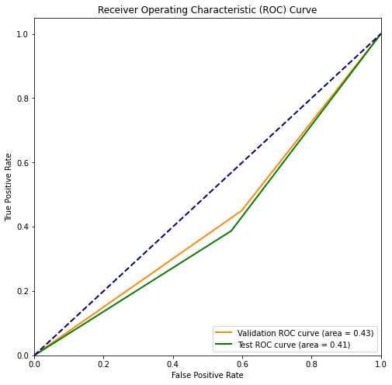
svm_classifier_linear = SVC(kernel='linear', random_state=42)

